Sync Project Manager Manual

1.0 Overview
1.1 Background
The Project Manager (PM) application presented here was built on top of the Sync framework and models some of the functionality of the Groove PM Tool. The functionality includes creation of tasks and subtasks and task repositioning through promotion, demotion, and up and down movements. Sync PM can also display the project tasks, their time dependencies, and their parent-child relationships visually in the Timeline option. The following Groove PM functionality was not implemented: filtering of tasks according to owner and status, attaching objects to tasks (such as documents), and cutting and pasting of tasks (although this can me modeled through the various move-task operations).
1.2 Issues Encountered
Real-time synchronization is sometimes a problem as replicated Project Manager instances appear inconsistent at times. However, this was identified as a possible sync issue because it cannot be reliable reproduced and consistency is regained through manual sync or future real-time sync operations.
When real-time synchronization, always make the first change to the replicated Sync PM object on the client that created the Sync PM.
1.3 Contribution to Sync
The Sync PM application uses many capabilities offered by the Sync framework. As such, during the development of the Sync PM, some framework issues were discovered: 1) Real-time synchronization of vectors containing elements that have recursive structures was found to be a problem. Various workarounds were proposed so that future users of the framework can get around this problem; 2) clients running on the same host interfered with each other and caused improper object replication and synchronization; and 3) an object to be synchronized cannot have both properties and sequences of elements.
Discovering these issues helped to create a more robust framework and helped other students quickly solve these problems through proposed workarounds.

2.0 The User Interface
2.1 Task Nodes
When the Sync PM is started, a default Root Task is created. This task cannot be moved (that is, it cannot be promoted, demoted, or moved up or down). Its other properties can be modified. There is always one Root Task which represents the project as a whole. For example, the start and end dates of the Root Task are the start and end dates of the entire project.
2.2 Task Relationships
If a Task A is in Task B’s subtask list, then A is an immediate subtask of B, and B is a parent of A. Each task, except the Root Task, has one and exactly one parent, while the Root Task has no parent. A task may have 0 or more immediate subtasks. If task A is an immediate subtask of Task B, and Task A is a parent of task C, then task C is a distant subtask of task B.
2.3 Invoking Methods
There are two ways of invoking methods on a task. First, the user can right-click on a class and select one of the items from the menu. All the commands on the menu are dependent of the currently selected task except the “Show Timeline” method (it always displays all the tasks). Second, the user can select a task and then click on the “Task Node” menu option at the top of the window. Once again, all the commands on the menu are dependent of the currently selected task except the “Show Timeline” method.
2.4 Task Creation and Removal
A task is created by selecting a current task and calling the “Add New Task” method for that task. Thus, adding a Task always results in adding a subtask to an already existing task. When a task is added, the user can specify the task owner and title, while the start and end dates of a task are set to equal the parent’s start and end dates. The user can change the start and end dates once the actual task is added to the Sync PM display.
A task is removed by selecting it and calling the “Remove Task” method. It results in the removal of the currently selected task and all of its subtasks, both immediate and distant.
2.5 Task Promotion and Demotion
Promoting a task means that it becomes as important as its parent task. Promotion is accomplished by calling the “Promote Task” method on a selected task. As a result, it is moved to the same level as its parent task. When a task is successfully promoted, it will appear immediately below its old parent task at the same task level as its old parent task. However, if a task is an immediate subtask of the Root Task, then it cannot be promoted because this would have duplicate Root Tasks which is not allowed by the Sync PM.
Demoting a task A means that it becomes an immediate subtask of the task currently at the same level, say task B. Task A becomes first subtask in B’s subtask list. However, if A is currently the first (or only) subtask in its parent’s subtask list, A cannot be demoted because B does not exist. Demotion is accomplished by calling the “Demote Task” method on a selected task. Task demotion can cause the start and end dates of the new parent to be updated.
2.6 Moving Tasks
If a task is not the first sub-task in the parent’s sub-task list, a task can be moved up in the list by calling the “Move Task Up” method on a selected task. If a task is not the last sub-task in the parent’s sub-task list, a task can be moved down in the list by calling the “Move Task Down” method on a selected task.
2.7 Changing Start and End Dates
Start and end dates can be changed for any task. However, a parent’s start date cannot be set later than the most recent start date of any of its sub-tasks. Similarly, a parent’s end date cannot be set earlier than the latest end date of any of its sub-tasks. As a result, changing the start or end date of a task can result in updating the parent start or end dates. This can cascade all the way to the Root Task.
Always change the dates using the “Set End Date” and “Set Start Date” methods. Never enter the date manually in the date field unless the format is guaranteed to a valid dd/mm/yyyy input.
When entering dates, please enter dates between 1/1/1901 and 31/12/9999. This was a design decision because Y10K compliance was deemed not necessary for the scope of this project.
2.8 Timelines
The timeline can be displayed by calling the “Show Timeline” method. The timeline range will be from the start to the end dates of the selected task and these dates are displayed at the top of the timeline. Each task in the timeline is represented as a rectangle that spans the dates from its start and end dates. Also, each task has the task name included in the rectangle. Finally, each task is of two colors: the first color, which is shown at the front of the rectangle, displays the color of the parent task, while the second color is the color associated with the current task. Thus, parent and subtask relationships are preserved through color. Please note that colors repeat if a task is more than 10 levels deep so a task may appear to have more than one parent. This needs to be addressed in future revisions of the Sync PM.

3.0 Collaboration Scenarios
3.1 Project Manager Collaborates with the Lead Project Tester
Please note that I tried creating screen shots for all the steps, but there were just too many screens to cover so instead I outline the steps involved in the collaboration and the shots of the screens after every step.
In this collaboration scenario, Joe, the project manager, wants to manage the “Sync PM 2.0” project, the next release of the Sync PM, through Sync PM 1.0. He has all the development time data from the programmers, so he can create the programming tasks, but he is missing testing time data. He will require the help of Judy, the lead tester for the Sync PM 2.0, to create the tasks for testing.
First, the Sync Server, Joe’s Sync Client, and Judy’s Sync Client are started. The clients are set to function synchronously.
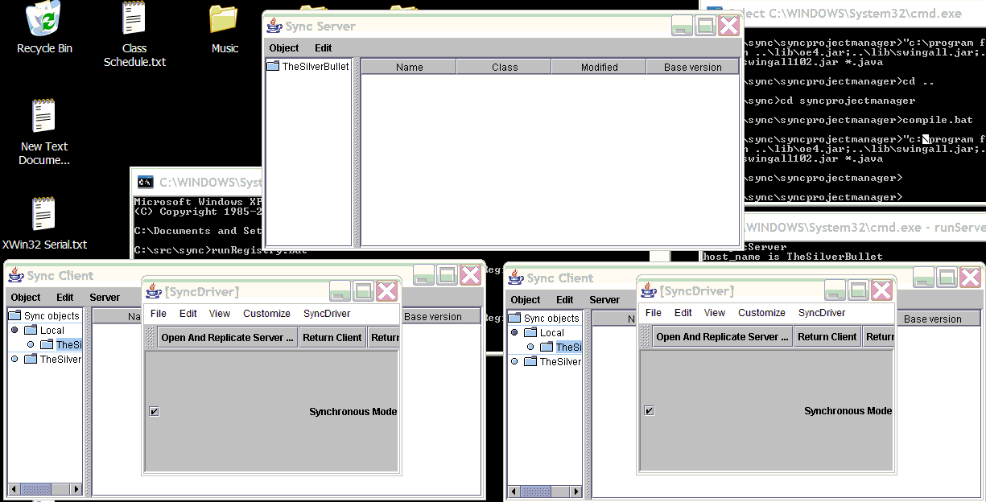
Then, Joe creates the Project Manager instance and populates the Root Task title and owner as “Sync 2.0” and “Joe”, respectively.
- Joe adds a new Project Manager to his Sync Client.
- He enters “Sync 2.0” in the Name field and “Joe” in the owner field.
- He leaves the start and end dates at the default “1/1/2004” value.
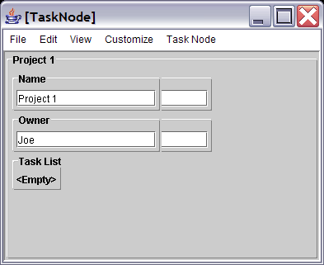
He then adds a subtask to the Root Task called “Development. Since he has the development time data, he enters himself as the owner of the “Development” task.
- Joe right-clicks on the “Sync 2.0” task and clicks on the “Add Task” option on the menu that pops up. This brings up a new window for the new task.
- He enters “Development” in the Name field and “Joe” in the owner fields of the new task.
- He right-clicks in the window of the new task and selects “Set End Date”. This pops up another window for the end date of the new task being added (i.e. the “Development” task). He sets the Day field of the end date to 4, because he believes the development will take 4 days (from 1/1/2004 to 4/1/2004) and then selects “File/Done” from the menu on top of the window. This updates the end date of the “Development” task.
- He then clicks “File/Done” from the menu on top of the “Development” task window.
- Notice that Judy’s Project Manager window is updated to have the new task. Also notice that the root task, the “Sync 2.0” task, had its end date updated to 4/1/2004 because one of its children, “Development,” has that end date.
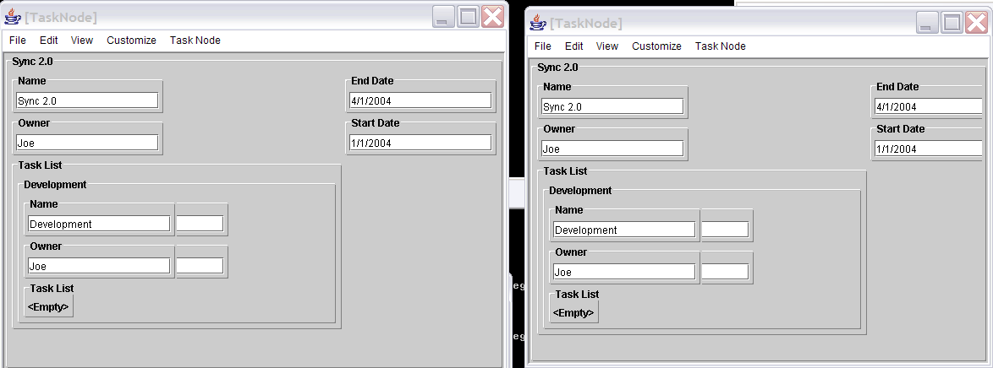
At this point, he calls Judy and tells her that he will be adding development tasks and that she needs to enter testing tasks for each of them. They can thus work synchronously if Judy immediately adds testing tasks to the new development tasks Joe creates, or they can work asynchronously if Judy waits for Joe to add all the tasks and later she adds the testing tasks. Here, we show the asynchronous case.
At first, Joe has only two development subtasks called “Add Owner Filter” and “Add Cut/Paste.” He creates both of them. The process is similar to creating the “Development” task except instead of selecting the Root Task when the new tasks are added, the “Development” task is selected because Joe is adding subtasks to it. The two below figures show the resulting main display and the resulting timeline of the overall project.
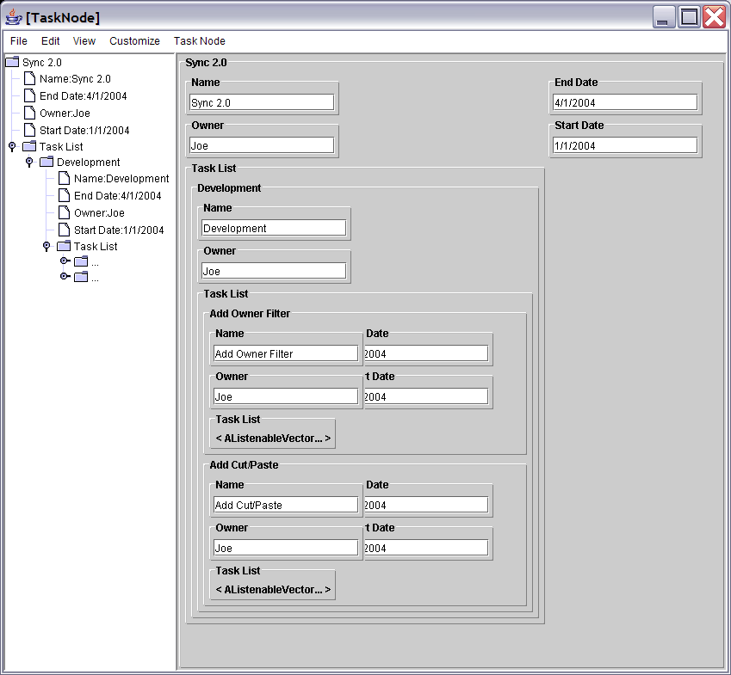
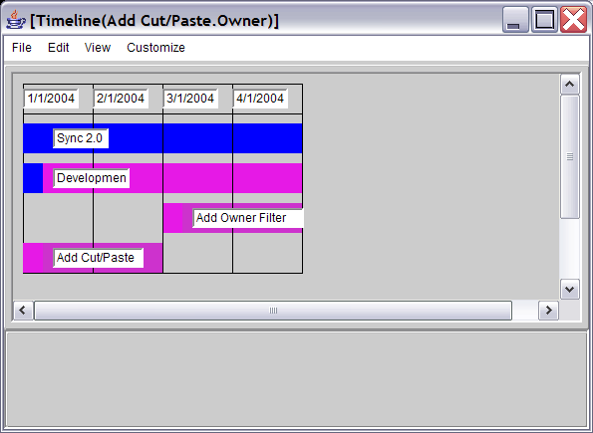
Then, later in the day, Judy sees the tasks Joe added that have no corresponding test task and she adds a subtask for testing for each of the development tasks. The test tasks start after, and so clearly end after, the corresponding development tasks. This results in the updates of the date values of all the parent tasks because the actual development task time has been expanded by the test time. For example, the testing of the “Add Owner Filter” will take from 5/1/2004, when the development of this task finishes, to 6/1/2004. Thus, the testing will take 2 days. Notice that this updates end dates of the parent tasks of the test tasks, and eventually the main project node “Sync 2.0” to 6/1/2004.
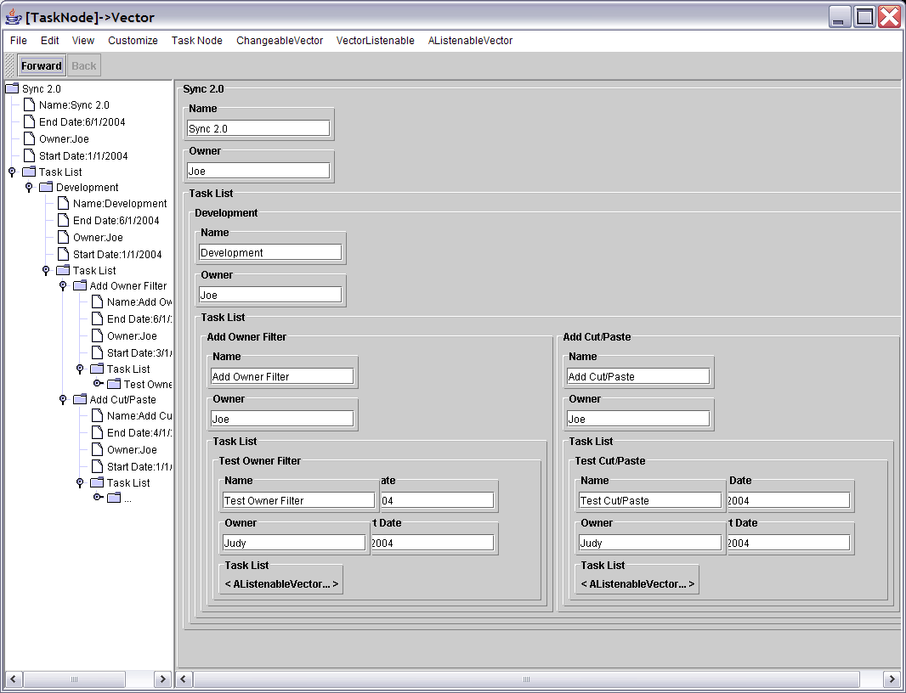
When all the tasks are added, Judy displays the Timeline for the project. Notice how the timeline captures all the time dependencies between the tasks. It also uses the color coding explained in section 2.8 to present the parent-subtask relationships.
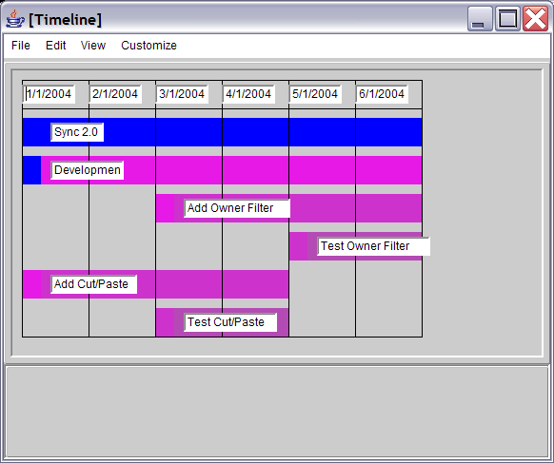
Joe later decides to move push back the start date of the “Add Cut/Paste” task. Unfortunately, he must first consult with Judy because the new start date is later than the start date of the associated test task. He can of course change the start of the test task manually but we assume that Joe is nice and will ask Judy first. This motivates the future upgrade to the Sync PM of notifying the users via email when the tasks they own are changed by somebody else.
3.2 Sync PM as an Outline
The Sync PM can also as an Outline by ignoring the date fields present in the task objects. But the date objects can be used to enhance the outline creation.
First, the user can populate the dates for each timeline object according to how long it took to write each of the sections. Later, these dates can be used for future estimates.
Second, the user can populate the start and end dates of each outline section prior to beginning writing that section in order to set completion goals for each section. This, for example, may be useful if a meeting is scheduled to discuss various issues, and prior to the meeting, the person scheduling it sends out an instance of the project manager and asks everyone participating in the meeting to add any issues they want to discuss and the time estimates required for each issue discussion.

4.0 Conclusion
4.1 Future Work
Adding filters for the displayed nodes, both in the main view and the timeline, in terms of owners should be added. That is, if a specific owner is selected, only his or her nodes should be displayed in the main and timeline views.
Also, functionality to cut and paste tasks should be added, although at the moment, this can be accomplished by the various task move operations.
Finally, if a user owns a node and a change is made to it, that user should be notified via email or IM. This functionality can be added to the Sync PM in the future.

Appendix A – Programming Interface of Sync Objects
The only Object that is actually replicated by Sync is the TaskNode object. The following is the interface:
- addTask (TaskNode newTaskNode) – implicit parameter is “this” which is the parent node of the new task node.
- removeTask – implicit parameter is “this”
- promoteTask – implicit parameter is “this”
- demoteTask – implicit parameter is “this”
- showTimeline – displays all the tasks visually
- setStartDate (SyncPMDate newStartDate) – implict parameter is “this” whose start date is set to newStartDate
- setEndDate (SyncPMDate newEndDate) – implicit parameter is “this” whose end date is set to newEndDate

The other objects used in the application are the SyncPMDate and Timeline which are not actually replicated. The TimelineObject is an interface that must be implanted by any object which needs to be displayed in a Timeline.

